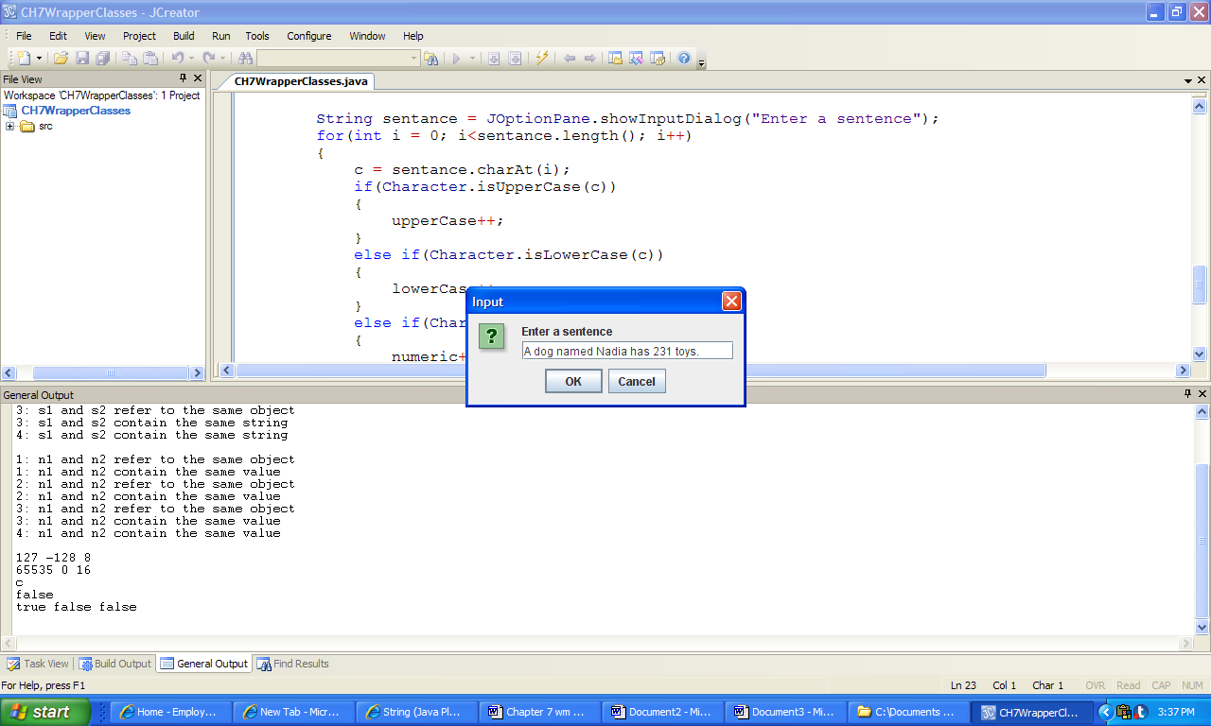 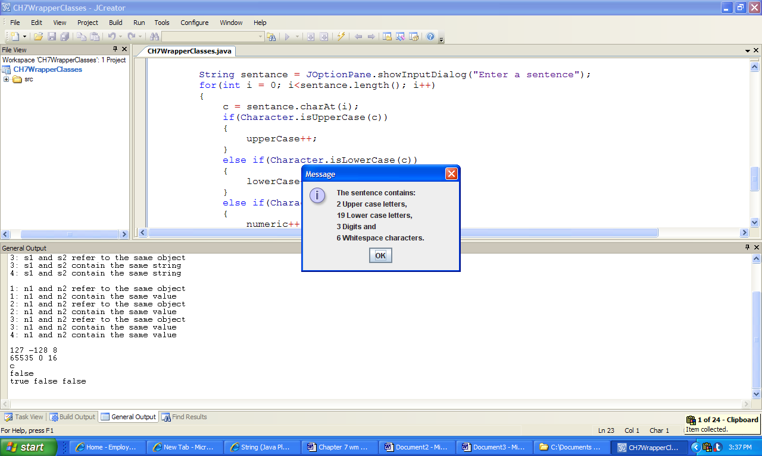

a) Input b) Output

**Figure 7.20 An input to the application ParseSentence and the resulting output.**